PHP Tutorial – processing forms with some validation

In this tutorial we are going to look at how to add some basic validation to the PHP scripts that process the user input received from forms. Before doing this tutorial you should have done the newnumyspace, forms and the previous PHP tutorials.

Task 1: Processing form input from various types of form element

In this exercise you are going to create a web form that allows the user to enter some details about themselves including the ability to choose the foods that they like (if any) from those provided. The form will contain a number of different types of element to capture user input, including text boxes, radio buttons, checkboxes and a select list. You will also create a PHP script that demonstrates how you can process the web form input.

- Create a new web page, enter/copy the following HTML code into it, save it as chooseFoodForm.html, upload a copy to newnumyspace and test it

<!doctype html>
<html lang="en">
<head>
<meta charset="UTF-8">
<title>Form to choose foods that you like</title>
</head>
<body>
<form action="chooseFoodProcess.php" method="get">
<h1>Foods that you like</h1>
<fieldset>
<legend>About you</legend>
<label>Forename
<input type="text" name="forename" accesskey="f">
</label>
<label>Surname
<input type="text" name="surname" accesskey="s">
</label>
<label>Your level of study
<select name="studyLevel">
<option value="3">Three</option>
<option value="4">Four</option>
<option value="5">Five</option>
<option value="6">Six</option>
<option value="7">Seven</option>
<option value="8">Eight</option>
</select>
</label>
<div>
Gender
<label>Male
<input type="radio" name="gender" value="male" accesskey="m">
</label>
<label>Female
<input type="radio" name="gender" value="female" accesskey="e">
</label>
</div>
</fieldset>
<fieldset>
<legend>The foods that you like</legend>
<p>Click the foods you like</p>
<label>Bread
<input type="checkbox" name="food[]" value="bread" accesskey="b">
</label>
<label>Broccoli
<input type="checkbox" name="food[]" value="broccoli" accesskey="r">
</label>
<label>Chocolate
<input type="checkbox" name="food[]" value="chocolate" accesskey="c">
</label>
<label>Pizza
<input type="checkbox" name="food[]" value="pizza" accesskey="p">
</label>
<label>Yoghurt
<input type="checkbox" name="food[]" value="yoghurt" accesskey="y">
</label>
</fieldset>
<div>
<input type="submit" value="Send it!" accesskey="u">
</div>
</form>
</body>
</html>
The code sets up an html web form that allows the user to enter their forename(s) and surname and to specify their level of study, gender and any foods that they like from those provided.
Note that we have a checkbox for each type of food so the user can choose to pick as many as they like (or none). We have named each checkbox food[]. This is an array, allowing it to store the values of potentially multiple foods selected.
When the user clicks the submit button a script called chooseFoodProcess.php (as specified in the action attribute) will be invoked on the web server.
Notes:
- Information on using the forms accessibility and usability features could have been provided in some way but have been missed out here to keep the example code simple. You should add such usability and accessibility advice in the form’s that you create yourself
- CSS could also have been used to style the form, including its layout using the methods covered in the screen cast provided earlier on styling forms

Next you will create a PHP script to process the data sent from the web form and display the user’s forename, surname and the choices they made in the web browser.

- Create a new PHP script with (it should be HTML5 compliant as the output from the script will be web content), enter/copy the following code into it, save it as chooseFoodProcess.php and upload it to newnumyspace:

<!doctype html>
<html lang="en">
<head>
<meta charset="UTF-8">
<title>Food results</title>
</head>
<body>
<?php
$forename = $_REQUEST['forename'];
$surname = $_REQUEST['surname'];
$studyLevel = $_REQUEST['studyLevel'];
$gender = $_REQUEST['gender'];
$food = $_REQUEST['food'];
echo "<section>\n";
echo "\t<h1>Foods that you liked</h1>\n";
echo "\t<h2>Your details</h2>\n";
echo "\t<p>Forename: $forename</p>\n";
echo "\t<p>Surname: $surname</p>\n";
echo "\t<p>Level of study: $studyLevel</p>\n";
echo "\t<p>Gender: $gender</p>\n";
echo "\t<h2>Foods that you like</h2>\n";
echo "\t<p>You like the following type(s) of food: ";
foreach ($food as $foodType) {
echo "$foodType ";
}
echo "\t</p>\n";
echo "</section>\n";?>
</body>
</html>

Notice we have used a foreach to iterate over (loop through) each type of food in the food[] array.

- Test the form entering your firstname and surname, selecting a level of study, choosing a gender and by clicking all of the types of food. The result should look something like the following:

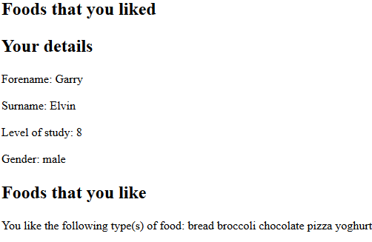

- Now test the form again but this time enter nothing in the text boxes and choose none of the options for everything – only click the submit button. The result should look something like the following:

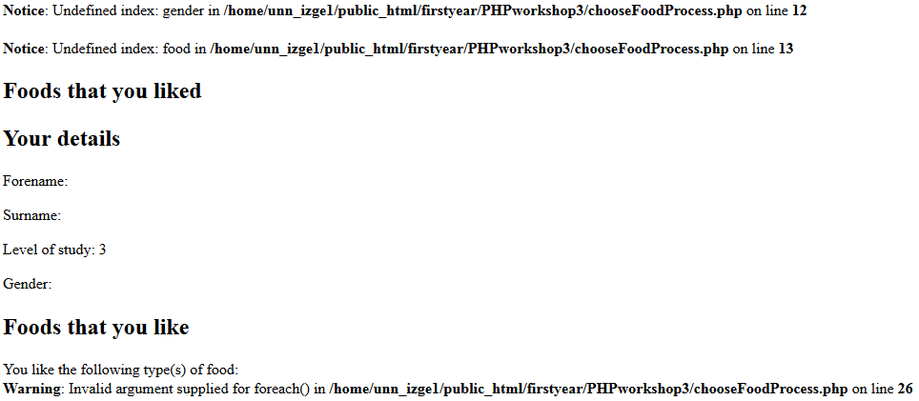

Explanation:

The $_REQUEST code gets the parameter values from the $_REQUEST array (which are stored there after being sent in the request stream of data sent from the form) by the specified index (the name of the appropriate form element, e.g. forename). Example:

$forename = $_REQUEST['forename'];

If a value has been entered / chosen for an element in the form, the $_REQUEST code will retrieve it. However, if a value for a form element was not received at the server, it leads to a PHP undefined index (nothing sent) error notice as above since no value can be found for the given element.

So what happened in the example above? Well, if you look at the web browser address bar you can see what was sent to the server in the query string when the submit button was clicked. It should look like the following

chooseFoodProcess.php?forename=&surname=&studyLevel=3

We can see that even though nothing was entered into the forename, surname and studyLevel elements in the form that something was sent. This is because in the case of text boxes, like the forename and surname ones, null blank values are sent if nothing is entered. In the case of select lists, like studyLevel, the value of the first option (in this case ‘3’) is sent if no option is selected.

For radio buttons like the gender ones and for checkboxes like those for the food choices, if the user doesn’t choose an option nothing is sent to the server for them. This means that error warning messages will be generated as shown above.

Note that as well as not entering anything / choosing any options in a form before clicking the submit button, a user having discovered the name of the processing PHP script, may try to call the PHP script directly without the form. They may do this either accidentally or deliberately to see what breaks.

If a user does this an undefined index message would be displayed for each element that a value was expected for, including in the above example, forename, surname and studyLevel as nothing would have been received.

We also got a warning about the foreach loop as no value was passed to it.

Task 2: Preventing undefined index error notice messages

In this exercise you are going to look at how we can prevent undefined index error messages. We can do this by detecting when nothing sent to the server for a form element and then assigning a value. To do this we are going to modify the code in chooseFoodProcess.php from task 1 to use ternary if operators, for example:

$gender = isset($_REQUEST['gender']) ? $_REQUEST['gender'] : null;

In pseudo-code we could describe what it is doing like this:

variable = if (test) then
assign this value
else
assign some other value
Except in the actual code the 'then' is replaced with ? and the 'else' is replaced with : and it's all put on one line, e.g.
variable = (test) ? what_if_true : what_if_false

Our test is to check the $_REQUEST array to determine whether a specified index (the name of a form element) has a value (is set) – and so was sent in the request stream - using the isset() function.

If the test using isset evaluates to true, the value sent for the form element will be stored in a variable. Otherwise a value of null will be stored in the variable, preventing error warning messages.

- Modify the $_REQUEST code for gender ($gender = $_REQUEST['gender'];) in the chooseFoodProcess.php script so that it handles possible undefined indexes for gender. The code should detect when nothing is sent to the server for gender, in which case it should assign a value of null to $gender.

Test it. You should see that no error messages are displayed if you don’t specify gender in the form.

- Modify the code in chooseFoodProcess.php to handle possible undefined indexes for forename, surname, studyLevel, gender and food.

No undefined index error messages should now be displayed if you don’t complete all or part of the form and click the submit button. In addition, no undefined index error messages will be displayed if you call the PHP script directly without the form.

Note: for now ignore the following message if you get it. We will handle that in task 4.

Warning: Invalid argument supplied for foreach() …

Our modified PHP script now prevents undefined index error messages if nothing is entered / no choice made. However, it would be better if we could do something like display a message asking the user to enter something into these text boxes. We will look at how to do that next.

Task 3: Prompting the user to enter data / make a choice
In this exercise you are going to look at how we can prompt the user to enter data / make choices for form elements for which we consider it essential to do so.

The PHP empty function can be used to evaluate whether a variable’s value is empty (null). We can use this to check whether the value of a variable set using a ternary if statement in the code for task 2 is null – remember that if it is null it means that nothing was sent from the form for a given form element.

If a variable is found to be null we can then output an appropriate message to the browser and prevent the code that attempts to display the forename etc. from being processed. For example, we could add code like the following to check whether the user has chosen a gender in the form from earlier:

if (empty($gender)) {
echo "<p>You have not selected your gender</p>\n";
}

Explanation:
If $gender is empty (null), then an appropriate message is generated.

- Modify the code in chooseFoodProcess.php by adding the following lines of code at an appropriate point to check whether the user has chosen a gender in the form:

if (empty($gender)) {
echo "<p>You have not selected your gender. Please try again.</p>\n";
}

- Now test the form without choosing a gender. The result should be something like the following:
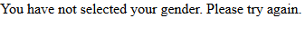

The fact that you had not entered a gender has now led to the display of a message saying that one was not entered.

- Modify the code in chooseFoodProcess.php so that the user will be prompted to enter / choose a forename, surname and study level if they had not done so with an appropriate message

You will have noticed that even though the user is prompted to enter/select a gender etc., the code intended to display what the user entered/selected is still used, e.g., echo "<p>Gender: $gender</p>"; and displays something like

- Modify the PHP code so that it displays the gender if the user selected one or otherwise displays a message saying that a gender was not selected. Do the same for forename, surname and study level

Task 4: Improving the handling of the checkboxes

Question: Why did we not require the user to click the checkboxes? The answer is that clicking checkboxes is optional – the user may select none, one or more of them. They are designed to be used in this kind of situation. For this reason, we don’t want to prompt the user to click them!

In this exercise we will improve our PHP script by getting it to display a message saying that no foods were selected rather than just displaying the following as it does at present,

“You like the following type(s) of food:”
Warning: Invalid argument supplied for foreach() …

- Modify the code in chooseFoodProcess.php so that it checks to see whether no foods were chosen (no checkboxes were clicked)

  - If none have been clicked, then the following message should be displayed,

“You did not like any of the foods listed”

Hint: you will need to check if $food is empty

  - Otherwise the selected foods should be displayed as at present

